1. **Java Installation**

* sudo apt update
* Install JDK

<https://download.oracle.com/otn/java/jdk/9.0.1+11/jdk-9.0.1_linux-x64_bin.tar.gz?AuthParam=1683886421_1603b66108615d82845d5ab9e22ec42e>

OR

<https://kenfavors.com/code/how-to-manually-install-oracle-java-9-on-ubuntu-16-04/>

**Step to Retrieve Java Path**

* dirname $(dirname $(readlink -f $(which java)))

# /usr/lib/jvm/java-11-openjdk-amd64

* **Change java**

$ update-alternatives --config java

1. **SSH Installation:**

* ssh-keygen -t rsa
* cat ~/.ssh/id_rsa.pub >> ~/.ssh/authorized_keys
* chmod 640 ~/.ssh/authorized_keys
* sudo apt-get install openssh-server
* ssh localhost

1. **Hadoop Configuration:**

* wget <https://dlcdn.apache.org/hadoop/common/hadoop-3.3.4/hadoop-3.3.4.tar.gz>
* tar xzvf hadoop-3.3.4.tar.gz
* Rename hadoop3.3.4 to Hadoop
* gedit ~/.bashrc

export JAVA_HOME=/usr/lib/jvm/java-11-openjdk-amd64

export HADOOP_HOME=/home/hadoop path of hadoop folder

export HADOOP_INSTALL=$HADOOP_HOME

export HADOOP_MAPRED_HOME=$HADOOP_HOME

export HADOOP_COMMON_HOME=$HADOOP_HOME

export HADOOP_HDFS_HOME=$HADOOP_HOME

export HADOOP_YARN_HOME=$HADOOP_HOME

export HADOOP_COMMON_LIB_NATIVE_DIR=$HADOOP_HOME/lib/native

export PATH=$PATH:$HADOOP_HOME/sbin:$HADOOP_HOME/bin

export HADOOP_OPTS="-Djava.library.path=$HADOOP_HOME/lib/native"

* source ~/.bashrc
* Switch to Hadoop Directory  
  /hadoop/etc/hadoop
* Edit Core-site.xml: gedit core-site.xml

<configuration>

<property>

<name>fs.defaultFS</name>

<value>hdfs://localhost:9000</value>

</property>

</configuration>

* Edit mapred-site xml :gedit mapred-site xml

<configuration>

<property>

<name>mapreduce.job.tracker</name>

<value>localhost:9870</value>

</property>

</configuration>

* Edit mapred-site xml :gedit hadoop-env.sh

export JAVA_HOME=/usr/lib/jvm/java-11-openjdk-amd64

* Edit mapred-site xml :gedit Hdfs-site.xml

Hdfs-site.xml

<configuration>

<property>

<name>dfs.replication</name>

<value>1</value>

</property>

</configuration>

1. Switch to root

hdfs namenode -format

1. Cd hadoop

Cd hadoop/sbin

./start-all.sh

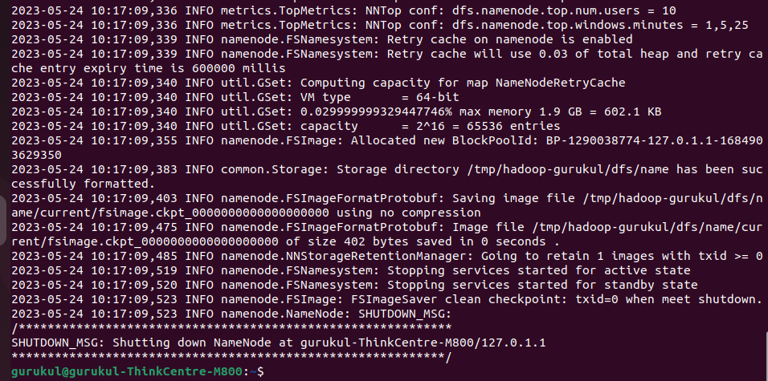jps

./stop-all.sh

Following Steps need to perform incase of any system Error:

Error localhost: rcmd: socket: Permission denied

<https://tecadmin.net/how-to-install-apache-hadoop-on-ubuntu-22-04/>

I also encountered the same thing, I did so I found that my pdsh default rcmd is rsh, not ssh, rsh and ssh remote login authentication is not the same, when installing hadoop I configured ssh localhost password-free login, but rsh is not possible.

so，try：

1.check your pdsh default rcmd rsh

pdsh -q -w localhost

See what your pdsh default rcmd is.

2.Modify pdsh's default rcmd to ssh

export PDSH_RCMD_TYPE=ssh

you can be added to ~/.bashrc, and source ~/.bashrc

3.sbin / start-dfs.sh

**Steps to Check Hadoop is Properly Installed or Not**

* Switch to hadoop bin
* hadoop fs -mkdir -p /user/gurukul/input
* <http://localhost:9870>

**Steps to Compiler and Run the application**

* Command to run Weathercode Mapreduce

javac -d . WeatherDriver.java WeatherMapper.java WeatherReducer.java -cp "$HADOOP_HOME/share/hadoop/mapreduce/hadoop-mapreduce-client-core-3.3.4.jar:$HADOOP_HOME/share/hadoop/mapreduce/hadoop-mapreduce-client-common-3.3.4.jar:$HADOOP_HOME/share/hadoop/common/hadoop-common-3.3.4.jar:~/WeatherMapReduce/*:$HADOOP_HOME/lib/*"

hadoop fs -put /home/gurukul/WeatherMapReduce/sample_weather.txt /user/gurukul

hadoop jar /home/gurukul/WeatherMapReduce/weather.jar WeatherDriver input out